

Student Name : Monisha. V

Register No : 312220258

Department : IIIrd B.com (General)

College : Jeppiaar College of Arts and Science



**"Analyzing Employee Attrition through Job Satisfaction Feedback" using Excel**



1.Problem Statement

2.Project Overview

3.End Users

4.Our Solution and Proposition



5.Dataset Description

6.Modelling Approach

3

/

21/202

4

**A**

**nnu**

**a**

**l**

**R**

**e**

**v**

**i**

**e**

**w**



8

.Conclusion

7.Results and Discussion

# PROBLEMSTATEMENT

To Analyse the Attrition i.e., Employee turnover by examining the Job satisfaction level by reviewing the feedback for job .



# PROJECT OVERVIEW

Th•i.s project aims to examine employee attrition by analyzing job satisfaction levels through feedback. The goal is to identify patterns in turnover, understand the factors influencing job satisfaction. The findings will assist in developing strategies to improve job satisfaction, reduce turnover rates, and promote a more stable, motivated workforce.



***WHOARETHEENDUSERS?***

## MANAGING DIRECTOR

-To Examine the Employee Turnover

* Human Resources (HR) Teams
* Management & Executives



* Team Leaders & Supervisors
* BusinessAnalysts

## ***OUR SOLUTIONAND ITS VALUE PROPOSITION***

**Conditonal Formatting** - To Highlight the Blanks cells and change the colour of the cell .

**Sort & Filter** - Remove the Blank Missing Values. **Pivot Table** - Summary of Employee Turnover from the Company through job satisfaction. **Formulas** - IFS (To get the Feedback for Job)

**Graphs**- (Bar Chart & Pie Chart) - FINAL REPORT on Employee Attrition

# Dataset Description

**EmployeeAttrition Dataset** - Kaggle.com

**Variables** : 35 Features

**Age** = <int> Numerical Values

**Attrition** = <fct> Text Values (Yes/No)

**Gender** = <fct> Text Values (Male/Female)

**Job Level** = <int> Numerical Values

**Job Satisfaction** = <int> Numerical Values

**Feedback for Job** = <fct> Text Values

**Performance rating** = <int> Numerical Values

**Total Working Years** = <int> Numerical Values **Overtime** = <fct> TextValues (Yes/No)

## ***THE"WOW"INOURSOLUTION***

New Formula Used : IFS

To Find out the Feedback for Job by

3

/

21/202

4

**A**

**nnu**

**a**

**l**

**R**

**e**

**v**

**i**

**e**

**w**



Analysing the Job Satisfaction Level .

# MODELLING

1. Dataset Collection - EmployeeAttrition Dataset
2. Dataset Preparation - Clearing Blanks, Filtering and Removing Blank data in the Dataset.
3. Using IFS formula to attain the Feedback for Job through Job Satisfaction Level (1,2,3,4) (Satisfied & Dissatisfied)
4. Insert Pivot Table to Summarize the Dataset on Employee Attrition based on Gender, Job Satisfaction Level, Attrition (Yes/No) and Feedback for Job.
5. Data Visualization using Bar Chart and Pie Chart to represent the turnover by gender and satisfaction level.
6. Final Report

## **RESULTS**

***PIECHARTVISUALIZATION***

***BARCHARTVISUALIZATION***

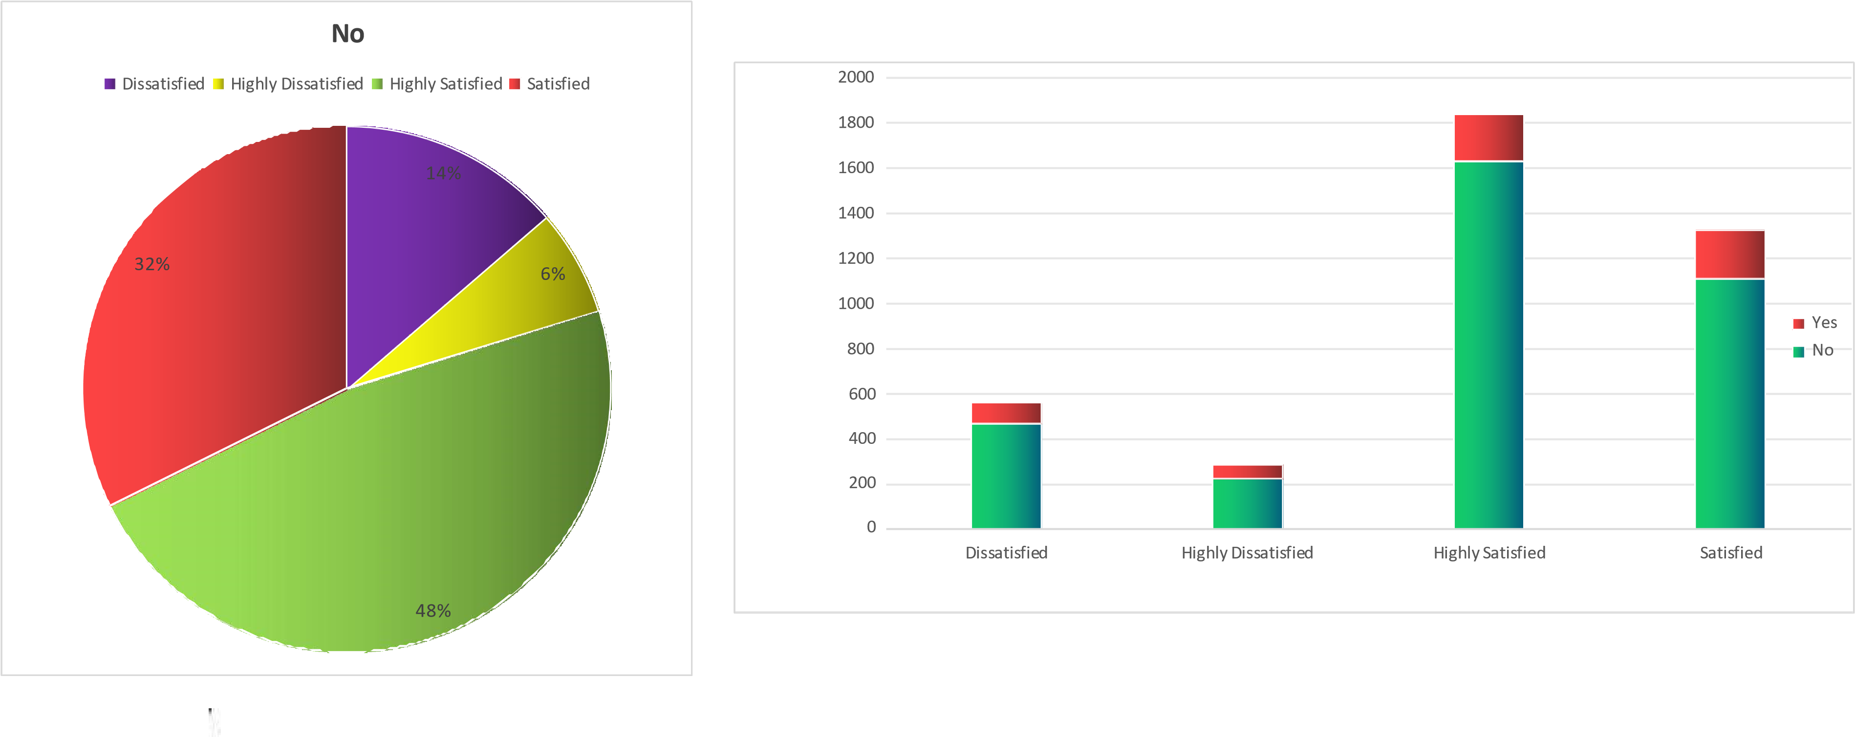

# Conclusion

In conclusion, this project highlights the importance of analyzing employee turnover through job satisfaction feedback to uncover underlying factors that contribute to attrition. By identifying patterns in employee dissatisfaction, organizations can gain valuable insights into the root causes of turnover. Implementing data-driven strategies based on these insights can enhance job satisfaction, improve employee retention, and ultimately reduce turnover rates, fostering a more stable, productive, and engaged workforce that supports long-term success.